Reporting Tools Do Not Use Cleanup Instructions:

1. Create a .csv file with a list of accessioning number you want to move to the Do Not Upload folder. The list of numbers must be in column 1 with no header. Number must be clean with no extra info besides the number itself (that means remove an tags like g,e, c3d etc). Save as a .csv; Excel files will not work. See below for example:

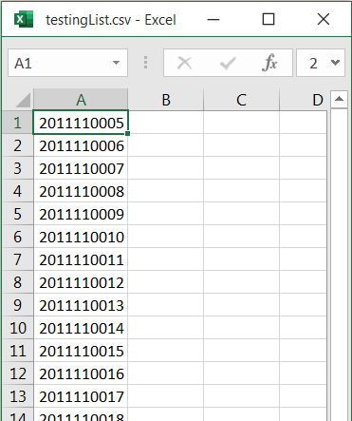

1. Save file as a standard CSV. Do not use UTF-8, MSDOS or mac versions. See below.

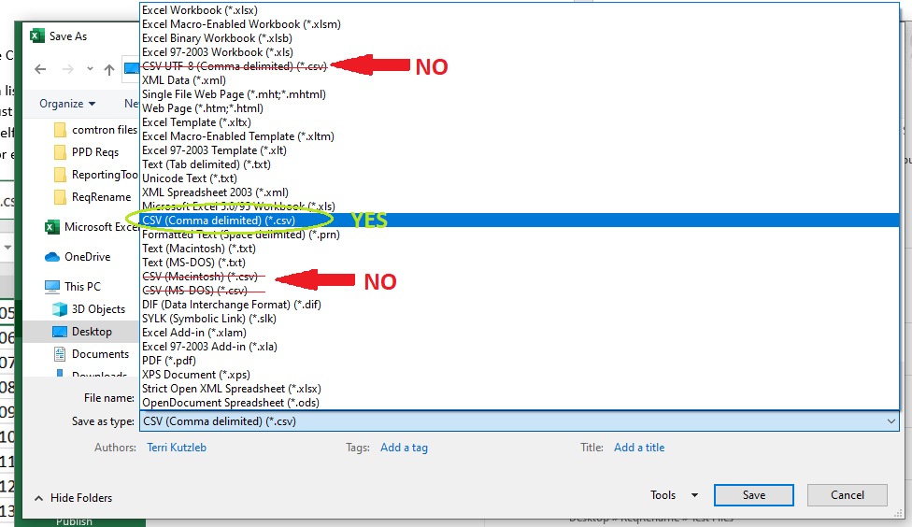

1. Open the Reporting Tools program and select “Do Not Upload File Cleanup”
2. A new page will open up with three file path fields and a few buttons.
3. Select the csv you created by clicking Browse in the first entry. You will only be able to click on .csv files. Pay attention next time if you created an excel file.
4. In the next section select the base folder that you want to organize. This should be your dated folder that contains your PDFs and a folder called “csv” (folder should not be capitalized).
5. The next section should populate automatically with the location of your CSVs. If it does not or the path is incorrect you can browse to the correct location if needed.
6. Click the Move Files Button. The program will do the following:

-Create sub folders for PAL and Do Not Upload if they already don’t exist

-Move all PDFs on your list into the DNU file

-Move all CSVs that match your list in to the created DNU/csv folders

:Notes:

Your Base folder should be set up like this (different names on pdfs):

Be sure that the csv folder is named csv/CSV with nothing else. If there are already PAL or Do Not Upload folders just leave them. Nothing will be overwritten.

When you are done it should look like this:

Notice that most of the files have been moved, but the ones on your list remain behind. The PAL and Do Not Upload folders were created for you.